DAILY ONLINE ACTIVITIES SUMMARY

|  |  |  |  |  |  |  |  |
| --- | --- | --- | --- | --- | --- | --- | --- |
| **Date:** | **6/06/2020** | | | | **Name:** | **Kavya.R.Shetty** | |
| **Sem & Sec** | **VI , A sec** | | | | **USN:** | **4AL17CS042** | |
| Online Test Summary | | | | | | | |
| **Subject** | | **PAP IA 3** | | | | | |
| **Max. Marks** | | **30** | | **Score** | | **25** | |
| Certification Course Summary | | | | | | | |
| **Course** | **Introduction to Cloud Computing** | | | | | | |
| **Certificate Provider** | | | **COGNITIVE CLASS IBM** | **Duration** | | | **10 hrs** |
| Coding Challenges | | | | | | | |
| **Problem Statement:**  1.Write a program in C to rotate an array by N positions. 2.Write a Python program to perform Cyclic Redundancy Check  3. Write a Python program to count the number of strings, provided string length is 2 or more and the first and last character are same from a given list of strings. | | | | | | | |
| **Status: Completed** | | | | | | | |
| **Uploaded the report in Github** | | | | **Yes** | | | |
| **If yes Repository name** | | | | <https://github.com/kavya-shetty765/DAILY-STATUS> | | | |
| **Uploaded the report in slack** | | | | **Yes** | | | |

# Online Test Details:

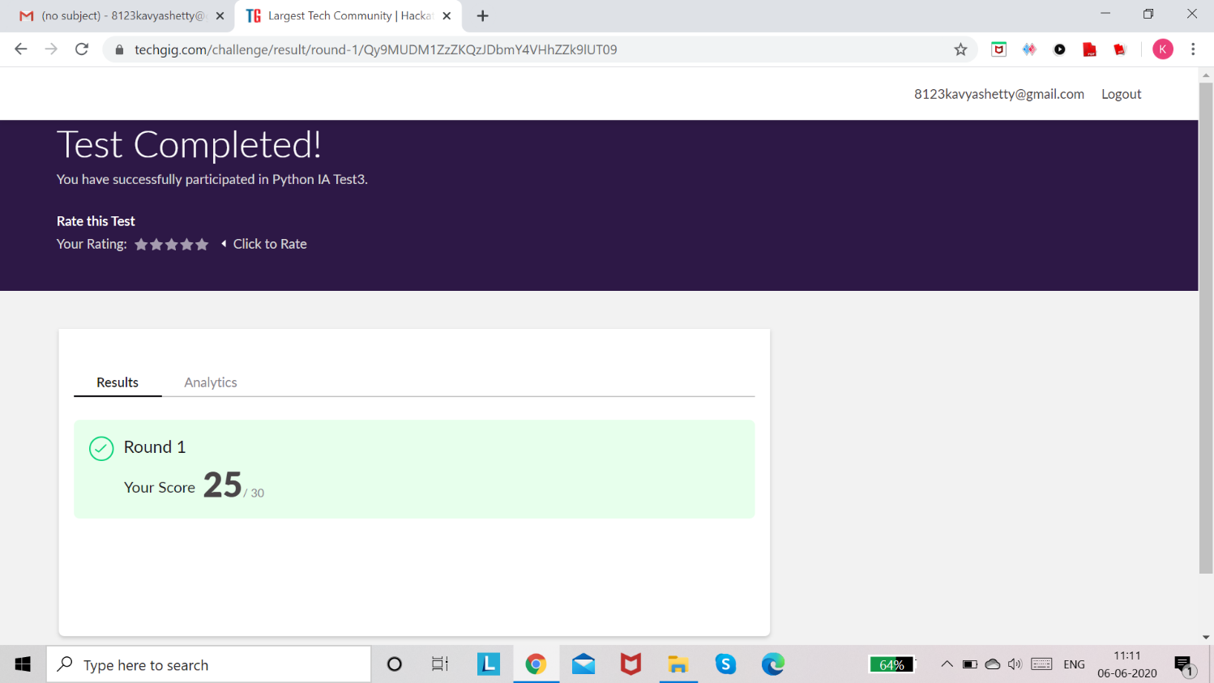

**Certification course Details:**

**Introduction to Cloud Computing:**

Today I learnt **Module 6 - “Emergent Trends, Cloud Native, DevOps and Application Modernization”**

In that I learnt about these topics,

* Hybrid Multicloud
* Microservices
* Serverless computing
* Cloud Native Applications
* DevOps on the Cloud
* Application Modernization

Refer GitHub account for Detailed information:

<https://github.com/kavya-shetty765/DAILY-STATUS/tree/master/6-06-> [2020/CERTIFICATION%20COURSE](https://github.com/nandithashetty/DAILY-STATUS/tree/master/6-06-2020/CERTIFICATION%20COURSE)

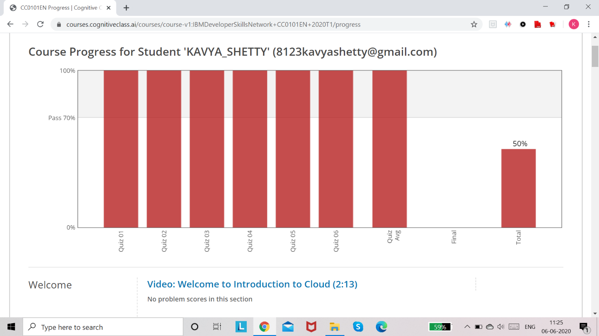

# Coding Challenge Details:

Refer the GitHub for Detailed Information:

<https://github.com/kavya-shetty765/DAILY-STATUS/tree/master/6-06-> [2020/ONLINE%20CODING](https://github.com/nandithashetty/DAILY-STATUS/tree/master/6-06-2020/ONLINE%20CODING)

The same report is also available in : <https://github.com/kavya-shetty765/DAILY-STATUS/tree/master/6-06-2020>